**Introduction**

Throughout history, humans have relied on a diverse array of tools to simplify tasks, driven by the inventive capabilities of the human mind to create various machines. These innovations have significantly improved human life by facilitating essential needs such as travel, industrial processes, and computing. Machine learning stands out among these advancements.

Arthur Samuel, renowned for his checkers-playing program, defined machine learning as the field enabling computers to learn without explicit programming. It empowers machines to efficiently handle data, bridging the gap when data interpretation proves challenging. As the volume of available datasets grows, so does the demand for machine-learning solutions across various industries. The essence of machine learning lies in its ability to glean insights directly from data, prompting extensive research to enable autonomous learning in machines without explicit programming. This endeavor engages mathematicians and programmers in exploring diverse methodologies to tackle this challenge, particularly in the context of vast datasets.(Batta Mahesh)

The field of machine learning offers a comprehensive algorithmic framework aimed at uncovering computational models that accurately depict empirical data and its underlying phenomena, often with minimal human intervention. Although still in its infancy and ripe with unexplored possibilities, machine learning has evolved to empower computers to undertake diverse tasks, such as identifying objects in images (critical for autonomous vehicles), enabling speech recognition (fueling voice-controlled technology), facilitating medical knowledge discovery (enhancing our comprehension of intricate diseases), and enabling predictive analytics (used in sales and economic prognostication), among numerous other applications. (Jeremy watt et al)

Machine learning (ML) is a discipline of artificial intelligence (AI) that provides machines with the ability to automatically learn from data and past experiences while identifying patterns to make patterns to make predictions with minimal human intervention.

Machine learning methods enable computers to operate autonomously without explicit programming. ML applications are fed with new data, and they can independently learn, grow, develop, and adapt.

**Types of Machine Learning**

**supervised learning**

In supervised learning, a dataset containing examples along with their corresponding correct responses or targets is furnished. Through this dataset, the algorithm learns to generalize its responses, ensuring accurate handling of all conceivable inputs. This process is often referred to as learning from exemplars.

This type of Machine learning involves supervision, where machines are trained on labelled datasets and enabled to predict outputs based on the provided training.

**Unsupervised Learning**

In unsupervised learning, the algorithm does not receive predefined correct responses. Instead, it focuses on recognizing patterns and similarities among inputs, grouping them together based on shared characteristics. This approach, termed density estimation, is a statistical method used in unsupervised learning. Unsupervised learning refers to a learning technique that is devoid of supervision. Here, the machine is trained using an unlabelled dataset and is labeled to predict the output without any supervision.

**Reinforcement learning:**

Reinforcement learning lies in between supervised and unsupervised learning paradigms. Unlike supervised learning where correct answers are provided, and unsupervised learning where no guidance is given, reinforcement learning informs the algorithm when its answer is incorrect but does not prescribe how to rectify it. The algorithm must explore various options and actions to discover the correct solution. Sometimes referred to as "learning with a critic," reinforcement learning involves a monitoring system that evaluates the answers but does not offer suggestions for improvement. Reinforcement learning is a feedback-based process, Here the AI component automatically takes stock of its surroundings by the hit and trial method, takes action, learns from experiences, and improves performance.

Machine learning diagram:

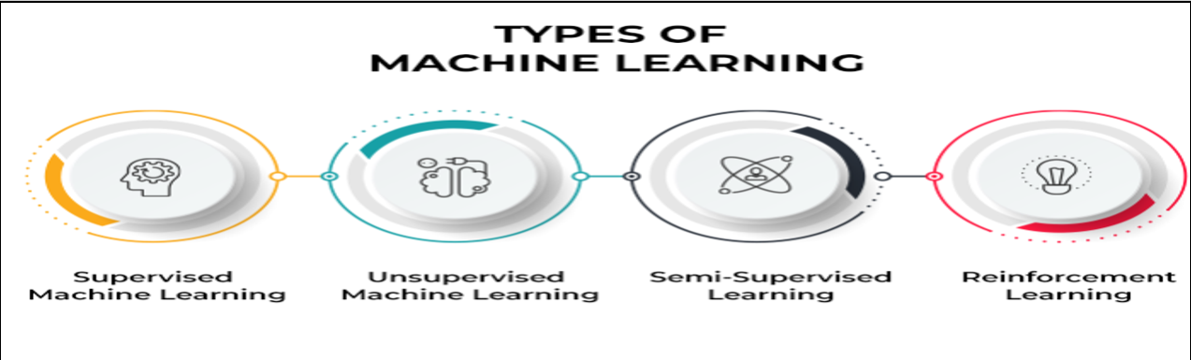

**Supervised Machine Learning:**

In the realm of machine learning, supervised learning entails the process of training a model to establish a relationship between input and output by leveraging labeled data pairs. These algorithms require external guidance to learn effectively. Typically, the dataset is partitioned into training and testing subsets, with the training set containing labeled output variables for prediction or classification. Various algorithms discern patterns from the training data and are subsequently applied to the test data for prediction or classification purposes. The workflow of supervised machine learning algorithms is depicted in the following figure, accompanied by an exploration of prominent algorithms in this domain.



**Regression:**

Suppose we wanted to predict the price of houses in a particular neighbourhood. We will first gather a training set of data consisting of houses in such neighbourhood with the known price. Next we will need to get feature(s) that are thought to be relevant to predicting the price of houses. The size(area covered by the house is one) is a potential feature that will determine the price of houses. , as we can expect that the higher the larger the area the more expensive the house should be. To connect the house price(output) to the area(input) we can train a simple linear regression line using our training data as shown in the figure below.

**Linear Regression:** Regression analysis involves the methodology of modeling straight lines to patterns within datasets. Within a linear regression model, the dependent variable, denoted as Y, is estimated based on k independent variables, represented as $X1$..., $Xk$, using a linear equation. The premise is that the value of Y at a specific time (or observation) within the dataset is governed by this linear equation.

$$Yt=b0+b1 X1+b2 X2+…+bkXk$$

**Classification:**

The task of classification in machine learning shares similarities with regression, albeit with a fundamental distinction. While regression predicts continuous output, classification aims to predict discrete values or classes. Classification scenarios manifest in various contexts, such as object recognition, where distinct objects within images are differentiated. Geometrically, classification often involves identifying a boundary line or curve that effectively separates different data categories in two dimensions. Moreover, numerous classification challenges involve multiple classes, as seen in tasks like handwritten digit recognition.

Machine algorithms are divided into three parts:

1. **Supervised ML algorithms:** I have a mathematical model(inputs, output), called supervised because I will with a sample of the output. We deal with terms like dependent and independent variables. A very simple example is linear regression.

**Regression:** works with continuous data(numbers that are not discrete) and has decimal point(3.33)

**Classification: Classification Ml problems are problems that are in classes or categories**

1. **Unsupervised**
2. **Reinforcement learning**

Reference

Machine Learning Refined: *Foundations, Algorithms, and Application. Jeremy Watt, Reza Borhani, Aggelos K. Katsaggelos*

Machine Learning Algorithms- *A review. Batta Mahesh (2019)*

*Notes on Linear regression analysis Robert Nau: Fuqua School of Business, Duke University*

**Algorithm Exploration (10%):**

**Literature Review (15%):**

**Real-World Application (15%):**